**BANA 7047 – Prof. Yan Yu**

**Individual Case II**

Last Name ___Newkold___________

First Name ___Tess_______________

M#____11434445_________________

Please use your **M#** to set the seed to draw a random sample.

Signature _______________________

Please use this as your cover page and follow **exactly** the required format below. Points will be deducted otherwise.

Please submit a WORD copy via blackboard with file name 7047-00X case#-last 4 digits of your M#.docx.

**Case reports**: Please have a cover page including above; **one-page executive summary** on Page 1, clearly stating:

* Goal and Background -- What is the problem?
* Approach -- What have you done?
* Major findings -- What do you find and what is your conclusion?

Organize, report, and interpret your **major** outputs with labeled figures and tables in your detailed report. Please do NOT include R code, data, and raw outputs.

|  |  |  |  |  |
| --- | --- | --- | --- | --- |
| |  |  | | --- | --- | | Case Two  Data Mining II  Tess Newkold  03-26-2019 |  | |  |  | |
| Boston Housing Data  Comparing Performance of Generalized Additive Models and Neural Networks to Generalized Linear Models and various Tree Models  German Credit Data  Comparing Performance of Generalized Additive Models and Neural Networks to Generalized Linear Models |

# Boston Executive Summary

Goal:

Our goal is to evaluate the performance of generalized additive models and neural networks to generalized linear models and various tree methods.

Approach and Major Findings:

To do this, a best model was chosen through a stepwise variable selection method. As well as various tree methods including a regression tree, bagging, random forest and boosting. The performance of these can be seen in table 1. The final model for GAM was achieved after running a few times to evaluate which variables should be linear and which should be smooth variables, this final model is shown here:

medv ~ s(crim) + zn + s(indus) + s(nox) + s(rm) + age + s(dis) + s(tax) + s(ptratio) + black + s(lstat) + chas + rad

From the table you can see that the neural network is better at predicting the median housing value in the Boston hosing data of an MSE of only 7.02.The neural network plotted below in Figure 1 shows the complexity of this model. No one knows how exactly a neural network works but it is very good at predicting with the caveat in decreasing interpretability.

Table 1. Summary of prediction error of all models.

|  |  |  |
| --- | --- | --- |
|  | MSE | MSPE |
| Linear Model | 21.57721 | 24.15419 |
| Regression Tree | 17.77735 | 19.53428 |
| Bagging | 18.98079 | 12.89348 |
| Random Forest | 11.20967 | 7.87853 |
| Boosting | 0.01416733 | 7.143803 |
| Generalized Additive Model | 8.361774 | 14.83328 |
| Neural Network | 4.12 | 7.02 |

Figure 1. Graphical representation of the neural network of the Boston Housing data



# German Credit Executive Summary

Goal:

Our goal is to evaluate the performance of generalized additive models and neural networks to a generalized linear model and classification tree.

Approach and Major Findings:

To evaluate which method has the best performance I looked at the misclassification tables, the misclassification rates, the ROC curves including the area under the curve, and cost for in-sample and out-of-sample performance for all four methods. This included a generalized linear model, classification tree, generalized additive model and neural net for the German credit data. This is shown in the tables and figures below for each individual method, in Table 2 a summary table is shown to compare the relative misclassification rates, cost, and area under the curve values. As you can see from table 2 the neural network method is slightly better at predicting the response variable. You can see that because the MR is slightly lower at 0.332 for the out-of-sample performance and the area under the curve is one of the highest among the bunch. As the neural network method is the best at predicting, below in figure 1 is a graphical representation of that neural network.

Table 2. Summary of prediction error of all models

|  |  |  |  |  |  |  |
| --- | --- | --- | --- | --- | --- | --- |
|  | MR | AUC | COST | MR | AUC | COST |
|  | In-Sample | | | Out-of-Sample | | |
| Logistic Regression | 0.3866 | 0.8090228 | 0.536 | 0.396 | 0.7893352 | .54 |
| Classification Tree | 0.32 | 0.8008187 | 0.34667 | 0.424 | 0.7192942 | 0.648 |
| Generalized Additive Model | 0.33733 | 0.8341237 | 0.46533 | 0.356 | 0.7987772 | 0.436 |
| Neural Network | 0.3133 | 0.8348144 | 0.462667 | 0.332 | 0.793437 | 0.46 |

Figure 1. Graphical representation of the neural net obtained by throwing all variables into the algorithm.

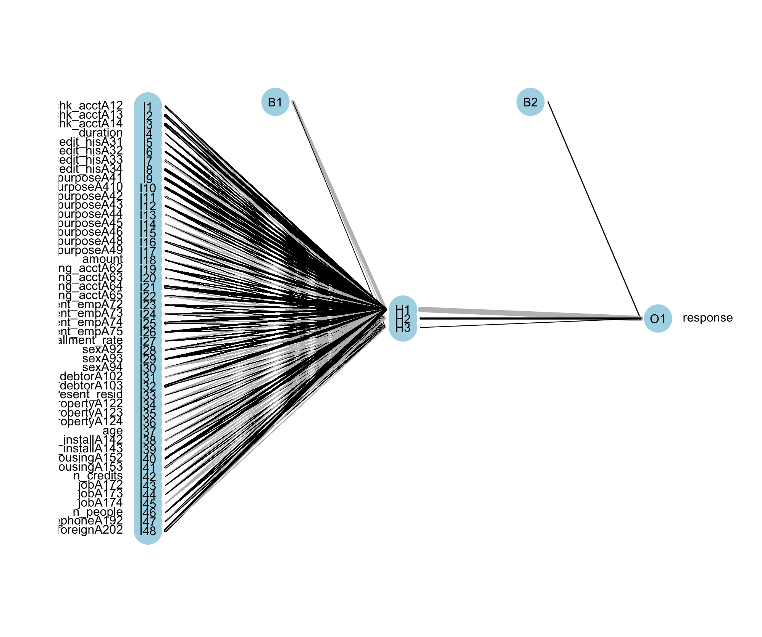

# Boston Housing Report

The purpose of this report is to compare generalized linear models and tree models to generalized additive models and neural network models. The best linear model is: medv ~ rm + lstat + ptratio + black + dis + nox + chas + zn + rad + tax + crim which is found through stepwise variable selection. The various tree methods include a regression tree, bagging, random forest, and boosting. In Figure 1, a pruned regression tree is shown using a cp of 0.021 which was obtained by plot in Figure 2. The respective MSE and MSPE are 21.57 and 24.15 this is a pretty low MSE, but it can be improved upon.

 Figure 1. Pruned tree using cp value of 0.021

Figure 2. Plot to obtain the cp value. We chose 0.021 because that is the first point that drops below the dotted line.



Bagging is the idea of putting the data into (n) number of bags and fitting trees to the data (n) times. By doing this repetitive model fitting it reduces prediction error greatly. This can be shown in Figure 3 below. The MSE is lower than a single regression tree at 12.89. This is because aggregated trees are better at predicting the response variable than one single regression tree.

Figure 3. Plot to show how many trees are needed to get a low prediction error while keeping the number of bags low.



Random forest is an extension of the bagging method and further reduces the prediction error to an MSE of 11.20. Figure 4 shows how the number of trees impacts the out of bag error. Boosting is the last tree method and it further reduces the prediction error with a MSPE of 7.14 which is the lowest of all the advanced trees covered here. A nice thing about boosting is that is also shows the relative influence of each variable on the response variable, this is shown in Figure 5.

Figure 4. Plot that shows how the out of bag error decreases as the number of trees increases.



Figure 5. Plot shows relative influence of each variable in the model.



The main goal here is to compare these methods above to a generalized additive model prediction performance and neural network. Here the MSE further drops to 5.608295 meaning it is a better model for predicting median housing value. First, I made a model including all variables as smooth except chas and rad since these are categorical, then upon evaluation it is clear that ptratio needed to be changed to a linear variable. The final model came out to be: medv ~ s(crim) + zn + s(indus) + s(nox) + s(rm) + age + s(dis) + s(tax) + ptratio + s(black) + s(lstat) + chas + rad. How these variables plot against the response variable medv are shown below in Figure 6.

Figure 6. Plots of all smooth variables against response variable

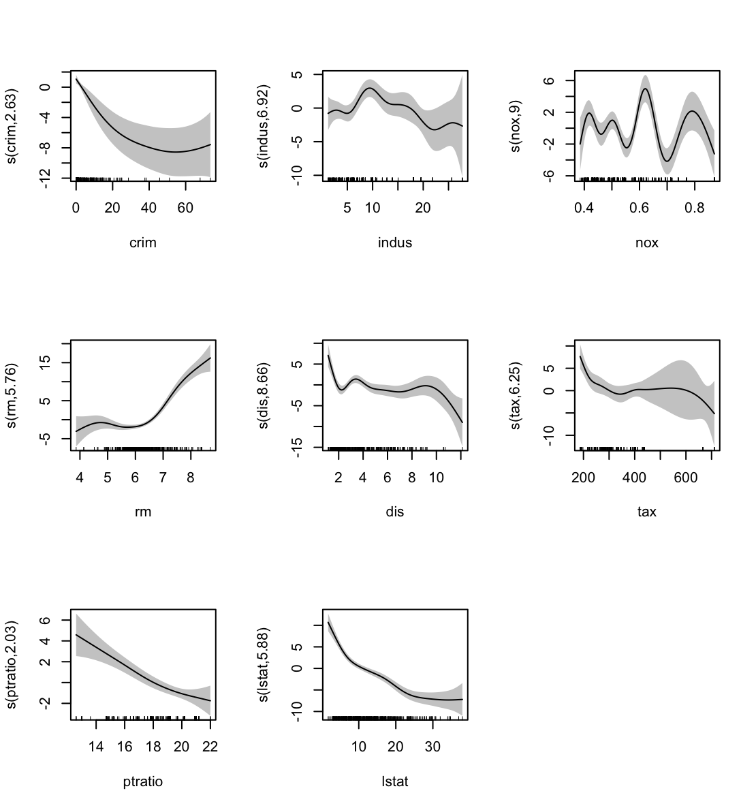

Neural network models are the most complex and the least understood, but we use them because they are extremely accurate and predicting response variables. The graph of the neural network can be seen in Figure 7 below. The MSE is extremely low at just 7.02 which is much less than any of the other methods used. It is obvious that performing a neural network when possible is the best choice in reducing prediction error. Even though it is not well understood it is still the best method here.

Figure 7. Plot of the neural network for Boston housing data.



# German Credit Report

**Generalized Linear Model**

To evaluate the performance of generalized additive models and neural nets on the German credit data we first need something familiar to compare it to. The first thing I evaluated is the performance of a general logistic model on the German credit data then a classification tree. The model achieved using stepwise variable selection is:

*response ~ chk_acct + duration + credit_his + amount + saving_acct + installment_rate + sex + other_debtor + age + other_install + n_people + telephone + foreign*

The first thing we can look at to evaluate performance is the misclassification table (Table 1) for in-sample performance. The misclassification rate for in-sample and out-of-sample is 0.3866 and 0.396 respectively. The cost for in-sample and out-of-sample is 0.536 and0.54 respectively.

Table 1. Misclassification Table for In-sample and out-of-sample

|  |  |  |  |
| --- | --- | --- | --- |
| IN | | Predicted | |
| 0 | 1 |
| True | 0 | 261 | 262 |
| 1 | 28 | 199 |

|  |  |  |  |
| --- | --- | --- | --- |
| OUT | | Predicted | |
| 0 | 1 |
| True | 0 | 87 | 90 |
| 1 | 9 | 64 |

Figure 1. ROC curves



**Classification Tree**

The classification tree can be seen in Figure 2 as well as the pruned tree on the right. The misclassification rate for in-sample and out-of-sample is 0.32 and 0.424 respectively. The cost for in-sample and out-of-sample is 0.34667 and 0.648 respectively. The misclassification tables are shown below in Table 2, and the ROC curves in Figure 3.

Figure 2. Classification Tree and pruned tree on the right.

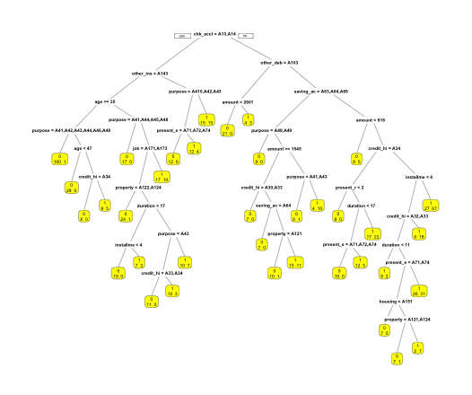

Table 2. Misclassification Table for In-sample and out-of-sample

|  |  |  |  |
| --- | --- | --- | --- |
| IN | | Predicted | |
| 0 | 1 |
| True | 0 | 288 | 235 |
| 1 | 5 | 222 |

|  |  |  |  |
| --- | --- | --- | --- |
| OUT | | Predicted | |
| 0 | 1 |
| True | 0 | 85 | 92 |
| 1 | 14 | 59 |

Figure 3. ROC curves for classification tree



**Generalized Additive Model**

My first generalized model I choose to smooth the variables duration, amount, and age based on my best educated guess. This model is:

*as.factor(response) ~ chk_acct + s(duration) + credit_his + purpose + s(amount) + saving_acct + present_emp + installment_rate + sex + other_debtor + present_resid + property + s(age) + other_install + housing + n_credits + telephone + foreign*

The three variables are plotted below in Figure 4, then based on the edf of the smooth variables from the above model I then chose to move age to a linear variable instead of smooth. This model is now updated to the below, age is bolded to see it easily:

*as.factor(response) ~ chk_acct + s(duration) + credit_his + purpose + s(amount) + saving_acct + present_emp + installment_rate + sex + other_debtor + present_resid + property* ***+ age +*** *other_install + housing + n_credits + telephone + foreign*

Figure 4. Plot of the three variables chosen to smooth, the third plot, age, is eventually dropped from the smooth variables and added to the linear variables, but I included it here to visualize.



The misclassification rate for in-sample and out-of-sample is 0.33733 and 0.356 respectively. The cost for in-sample and out-of-sample is 0.46533 and0.436 respectively. The misclassification tables are shown below in Table 3 and the ROC curves in Figure 5.

Table 3. Misclassification Table for In-sample and out-of-sample

|  |  |  |  |
| --- | --- | --- | --- |
| IN | | Predicted | |
| 0 | 1 |
| True | 0 | 294 | 229 |
| 1 | 24 | 203 |

|  |  |  |  |
| --- | --- | --- | --- |
| OUT | | Predicted | |
| 0 | 1 |
| True | 0 | 93 | 84 |
| 1 | 5 | 68 |

Figure 5. ROC curves for classification tree



**Neural Net**

The neural net is the least understood method that we have learned thus far, but typically has the best prediction performance. The neural net obtained is shown in figure 7. The misclassification rate for in-sample and out-of-sample is 0.3133 and 0.332 respectively. The cost for in-sample and out-of-sample is 0.462667 and 0.46 respectively. The misclassification tables are shown below in Table 4 and the ROC curves in Figure 6.

Table 4. Misclassification Table for In-sample and out-of-sample

|  |  |  |  |
| --- | --- | --- | --- |
| IN | | Predicted | |
| 0 | 1 |
| True | 0 | 316 | 207 |
| 1 | 28 | 199 |

|  |  |  |  |
| --- | --- | --- | --- |
| OUT | | Predicted | |
| 0 | 1 |
| True | 0 | 102 | 75 |
| 1 | 8 | 65 |

Figure 6. ROC curves for classification tree



Figure 7. Graphical representation of the neural net obtained by throwing all variables into the algorithm.

